Knowledge Engineering And Data Science
LAB
1.Grade Analysis Using Pie chart and Graph

import matplotlib.pyplot as plt
# 1. Store grades and corresponding number of students
grades = ['F', 'E', 'D', 'C', 'B', 'A', 'S']
students = [3, 4, 5, 8, 9, 7, 4]
total_students = sum(students)
# Calculate percentage distribution
percentages = [(count / total_students) * 100 for count in students]

# 2 & 3. Draw pie chart with grade labels and percentage values
plt.figure(figsize=(8, 6))

plt.pie(
students,
labels=grades,
autopct='%1.1f%%',
startangle=90
)
plt.title('Percentage Distribution of Students by Grade')
plt.legend(grades, title='Grades')
plt.show()
# 4, 5 & 6. Draw bar chart
plt.figure(figsize=(8, 6))

bars = plt.bar(grades, students)

plt.xlabel('Grades')
plt.ylabel('Number of Students')
plt.title('Number of Students in Each Grade')
plt.legend(['Students'])

# Display exact number of students above each bar
for bar, count in zip(bars, students):
plt.text(
bar.get_x() + bar.get_width() / 2,
bar.get_height() + 0.1,
str(count),
ha='center',
va='bottom'
)

plt.show()

# 8. Identify maximum and minimum grades
max_students = max(students)
min_students = min(students)

max_grade = grades[students.index(max_students)]
min_grade = grades[students.index(min_students)]

print("Grade with maximum number of students:", max_grade)
print("Number of students:", max_students)

print("Grade with minimum number of students:", min_grade)
print("Number of students:", min_students)

# 9. Calculate percentage of students with A and S combined
A_students = students[grades.index('A')]
S_students = students[grades.index('S')]

A_S_percentage = ((A_students + S_students) / total_students) * 100

print("Percentage of students who secured A and S combined:",
f"{A_S_percentage:.2f}%")

OutPut :
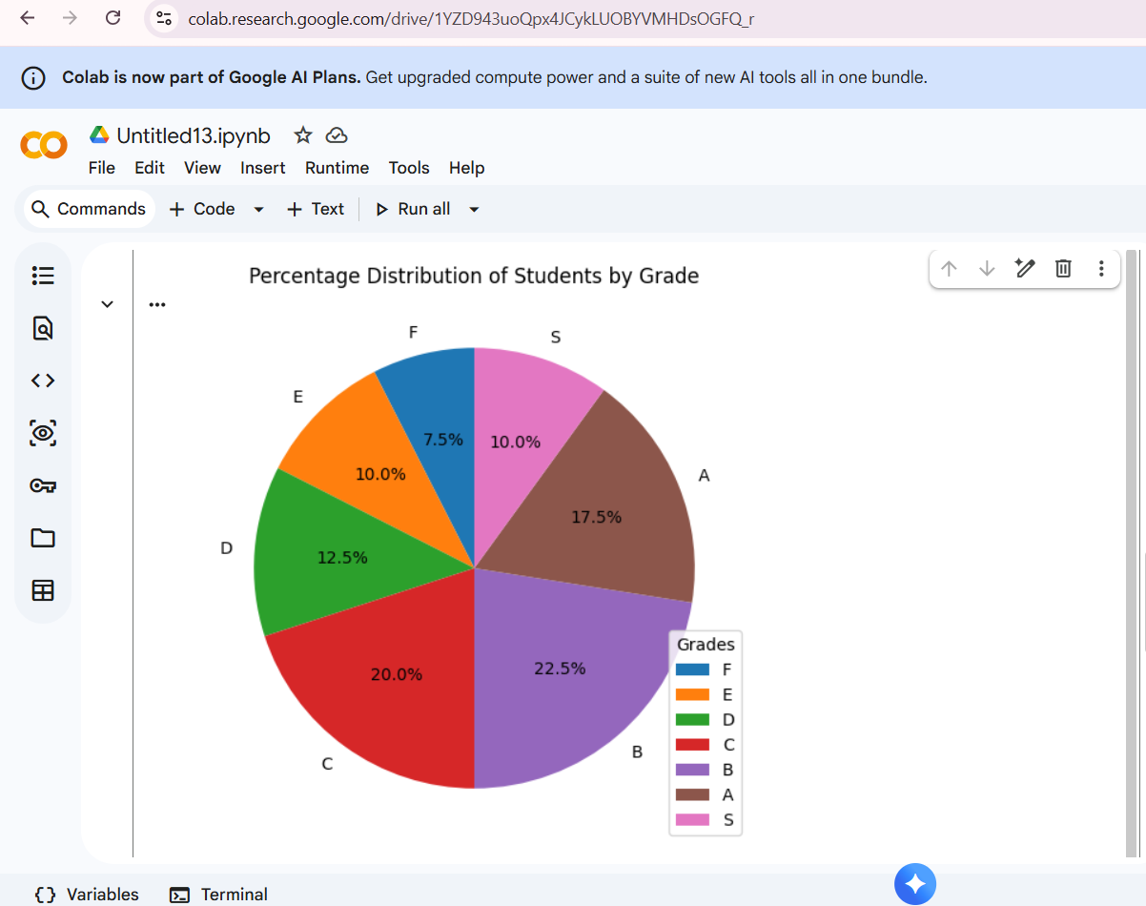

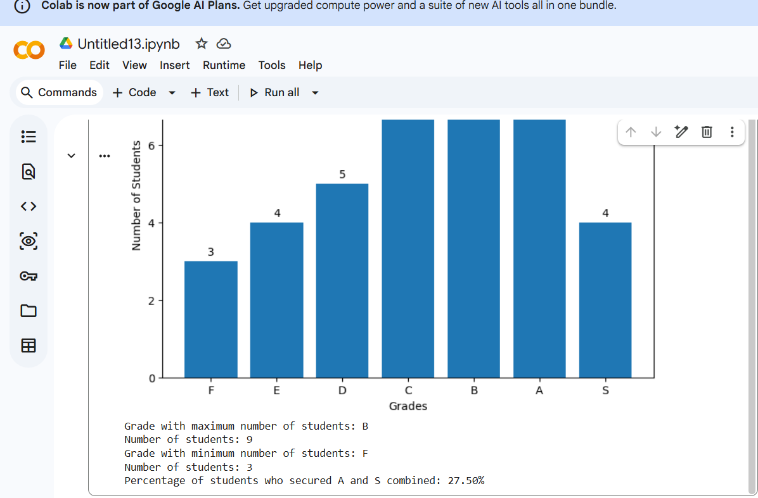
2. Semantic Network Using NetworkX

import networkx as nx

# Create a directed graph
G = nx.DiGraph()

# Add concepts and labeled relationships
G.add_edge("Dog", "Mammal", relation="is-a")
G.add_edge("Mammal", "Animal", relation="is-a")
G.add_edge("Dog", "Tommy", relation="has-instance")

# Display relationships
print("Semantic Network Relationships:")

for source, target, data in G.edges(data=True):
print(source, "--", data["relation"], "-->", target)

OUTPUT:
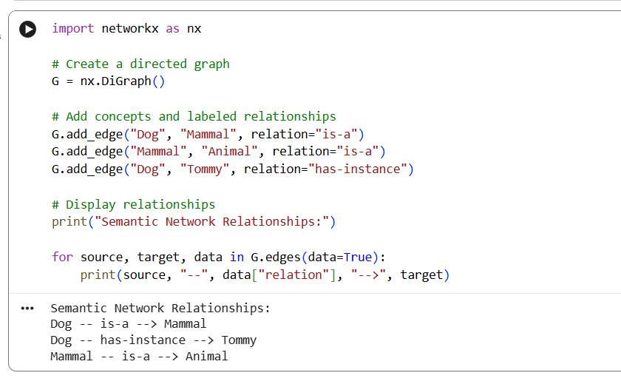

3.Frame-Based Knowledge Representation
# Create a frame using a dictionary
vehicle = {
"class": "Vehicle",
"brand": "Toyota",
"fuel_type": "Petrol",
"wheels": 4,
"color": "White"
}

# Display the frame
print("Vehicle Frame")

for slot, value in vehicle.items():
print(slot, ":", value)


